Piracy: The Next Industrial Revolution

As I write this paper on this day, June 5th 2014, I am reminded of a celebration soon to come as my birthday approaches. Yet in today's world I am reminded of the constant struggle for Civil Liberties that the Land of the Free as they, as the US Government is potentially passing a bill that allows Internet service providers, also known as ISPs, to be allowed to charge content providers for a faster conduit to consumers. In turn this will effectively end the neutrality zone called the Internet.
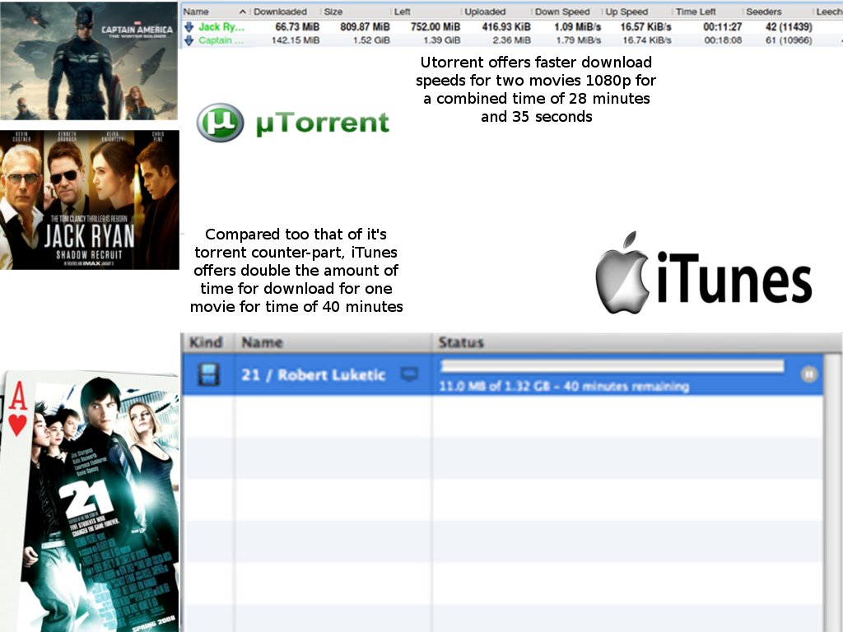
How does this pertain to the topic of Piracy? The answer is very complex but I will be narrowing it down to a few key components and events that lead to today's events. Piracy in itself is the embodiment of the movie and music industries failing to meet the needs of it's consumer on the technological level. This creates a whole new set of users on the World Wide Web (WWW) that reach out to this form of distribution rather than the store themselves. The industries standard way of distributing products across the globe is very flawed in today's technologically based society. When the consumer can download two 1080p Bluray quality movie from a given Torrent site in less than 28 minutes compared to the industries standard, iTunes taking 42 minutes. One can only wonder why people choose the alternative rather than the industries standard. Though this alternative is not legal in the United States and many other parts of the world. According to the RIAA;

“Making unauthorized copies of copyrighted music recordings is against the law and may subject you to civil liability. A civil law suit could hold you responsible for thousands of dollars in damages. Criminal charges may leave you with a felony record, accompanied by up to five years of jail time and fines up to $250,000. You may find this surprising. After all, compact discs may be easily be copied multiple times with inexpensive CD-R burning technology. Further, when you're on the Internet, digital information can seem to be as free as air. U.S. copyright law does in fact provide full protection of sound recordings, whether they exist in the form of physical CD's or digital files. Regardless of the format at issue, the same basic principle applies: music sound recordings may not be copied or distributed without the permission of the owner”.
Though pirating is illegal, according to Computer Weekly, “ Some 82% of people have downloaded content from the web illegally, according to a survey of more than 1,600 people”. And according to that same survey;
“The findings were:
- 82% of people who use the internet have downloaded a file illegally in the past.
- 24% have watched streamed movies online
- 32% have downloaded films that were still on at the cinema.

Of those who said they had downloaded files illegally:
- 35% have used torrent websites
- 78% have used peer-to-peer programs
- 52% have tried streaming illegal video and music content”.

As the result show, no matter how illegal it may seem to download illegal content, people are still able to do it and with ease. With the way information flows nowadays, one can easily and readily watch the new Godzilla (2014) movie at the comfort of their home rather than spend $12 at the local movie theaters. The argument that follows this form of distribution is that it costs the industry billions when people do participate in piracy. Though the root of the problem has not been addressed, there is an obvious void between Consumer and the Producer of said entertainment goods. This void is being filled by piracy and the movie and music industries are doing their best to destroy this form of distribution rather than learn from it and fill in that void that piracy fills in. Numerous new and innovative software applications such as Hulu Plus and Netflix only support a select portion of movies compared to the unlimited options online. Take for example, the website http://www.thepiratebay.se, according to their official site they have 6,234,355 torrents as of June 6, 2014 at 1:46 pm. In 2012, according the the Netflix API (Application Programming Interface), they had roughly 9,381movies, 4,555 TV shows both for instant streaming and delivery combined they offer 13,886 movies and TV shows which is roughly 0.002% of what Pirate Bay offers.
How does all of this tie into civil liberties, well as a counter measure for people using piracy as a means to get their movies and music the industries in the past thirty years has passed 15 'Anti-Piracy' laws to insure that their investments are safely secure. From the Piracy and Counterfeiting Amendments Act in 1982 which according to Mike Masnick, “Increased criminal penalties for infringing records, tapes, and films from $25k & 2 years in jail to $250,000 and 5 years in jail. Also..made it so that first-time offenders could get the maximum” to the PRO-IP (Prioritizing Resources and Organization for Intellectual Property) Act, which Masnick puts plainly, “Increased civil penalties for infringement. Increased government seizure & forfeiture powers (which is how the government currently justifies its questionable domain seizures) and created a job in the White House to focus on greater enforcement”. Simply put the laws that are being put in place are progressively becoming more strict with each new bill. In 2012, Congress tried to pass the SOPA (Stop Online Piracy Act), and it was met with huge amounts of criticism from the online community. SOPA was a bill that would have had the government intervene and block and/or censor online content if they had copyright infringing material on the site. Julianne Pepitone at CNNMoneyTech put it best in her 2012 article, SOPA explained: What it is and why it matters. By stating, “It's a proposed bill that aims to crack down on copyright infringement by restricting access to sites that host or facilitate the trading of pirated content”.
Luckily the bill was not passed but fast forward to 2014, now the FCC (Federal Communications Commission) proposed rules that would allow rampant discrimination online, according to http://www.savetheinternet.com. The rules being set by the FCC allow big corporations such as AT&T or Comcast throttle connections by creating a two-tiered Internet. As savetheinternet.com puts it, “...fast lanes for those who can afford it and dirt roads for the rest of us”. This is not just limited to the connection speed of your Internet but also the applications such as Netflix that you use on your connection. If these new rules pass, competition and innovation will surely be destroyed as a result. Say for example that your a new IPO (Independent Business Owner) and you want to launch a new web application like YouTube, you would have to pay Comcast extra money for your users to use your application the way it was meant to be.

Though as a result of the Internet being such a wide and open environment, Governments fear the power of Internet Communities and the Internet themselves. Sites such as wikileaks.org deliver incriminating evidence of world governments stepping out of bounds such as the NSA spying on your everything digital. Evgeny Morozov said it best;
“The director of the FBI has been visiting Silicon Valley companies asking them to build back doors so that it can spy on what is being said online. The Department of Commerce is going after piracy. At home, the American government wants anything but Internet Freedom”.

At the end of the day, the one thing that all of these bills, laws, and the removal of civil rights have in common is the root issue of piracy and the entertainment industries lack of fulfilling it's consumers needs in this technologically developed society. No matter how one looks at it piracy in itself is illegal but there is a plethora of alternative solutions that can be implemented by the industries and the governments in the world without having to infringe on our civil liberties. Censorship and the United States Constitution do not go hand and hand. As stated in the United States Constitution, Amendment 1 states:
“Congress shall make no law respecting an establishment of religion, or prohibiting the free exercise thereof; or abriding the freedom of speech, or of the press; or the right of the people peaceably to assemble, and to petition the Government for redress of grievances”.
As time passes on the American people remain unaware that the First Amendment is being disregarded in Congress and in the Oval Office as bills like SOPA and these new FCC rules and regulations are being debated on. The implications alone show the total disregard of our Constitutional rights.

Bibliography

